**HOTEL BOOKING PROJECT**

**by Deep Chandra**



**Business Problems:**

The **Owesome Hotel** have seen high number of cancellation rates. They are dealing with some of the issues like Less revenue, more cancellations and less occupancy. Low cancellation rates is their primary goal in order to increase their efficiency in generating revenue and for us to provide thorough business advice to address this problem.

**Research Questions:**

1. What are the variables that affects the hotel reservation cancellations?
2. How can we reduce hotel cancellations rate?
3. How the hotel be assisted in making promotional decisions?

**Hypothesis:**

1. More cancellations occur when prices are higher.
2. When there is a longer waiting list, customers tend to cancel more frequently.
3. The majority of clients are coming from offling travel agents to make their reservations.

**Analysis and Report:**

I have transformed the data before doing the analysis. Below are the insights which I believe can help them to tackle the business problem and achieve their goal.

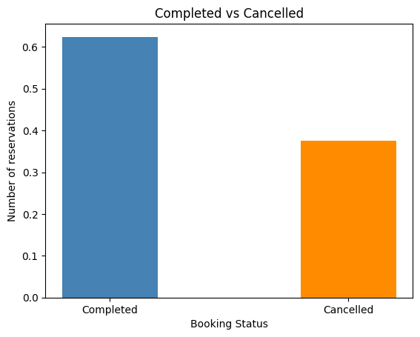

The above bar graph shows the comparison between cancelled and not cancelled reservations. There were almost 63% not cancelled bookings but 37% of cancelled bookings (which is a large number) from 2022-2024. That’s why these cancellations has the significant impact on the hotel’s revenue.

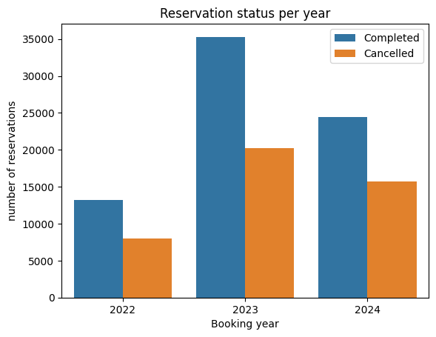

In above graph, we can clearly see that there were more number of completed and cancelled booking in year 2023.

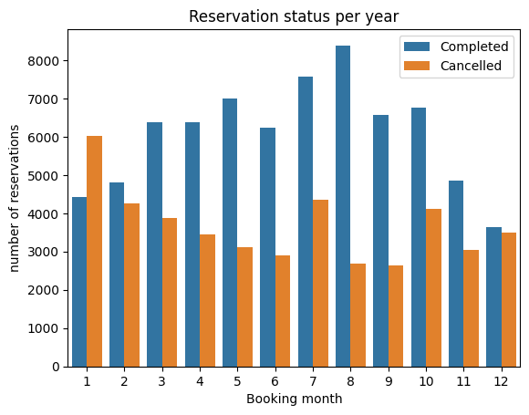

I have created the grouped bar graph to analyze the months with the highest and lowest reservation status. The highest number of cancellations are in January month of each year and the lowest were in September. Also, the highest number of complete bookings were in August and the lowest were in December. So, we have to check if high booking price is the reason for those cancellations.

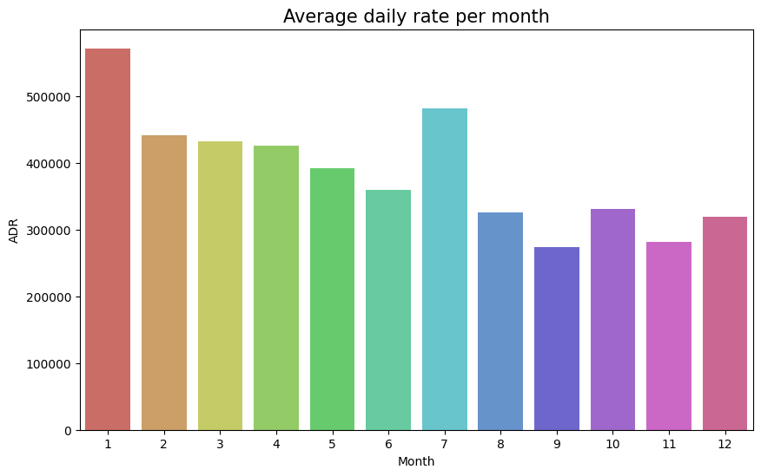

The above bar graph shows the average daily rate of the cancelled reservations for each month of every year. As we can see that the price was highest in January and lowest in September. Therefore we can say that the increased price may be the reason for more number of cancellations.

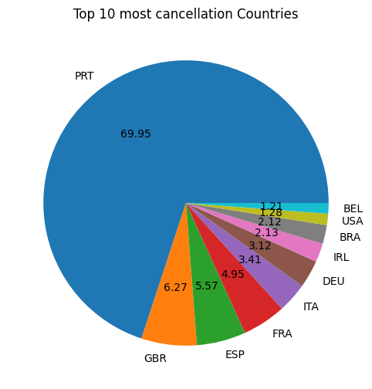

From the above pie chart, we can see that Portugal has the highest number of cancellations of almost 70% in comparison to other countries. Lets check from where the customers are making their reservations.

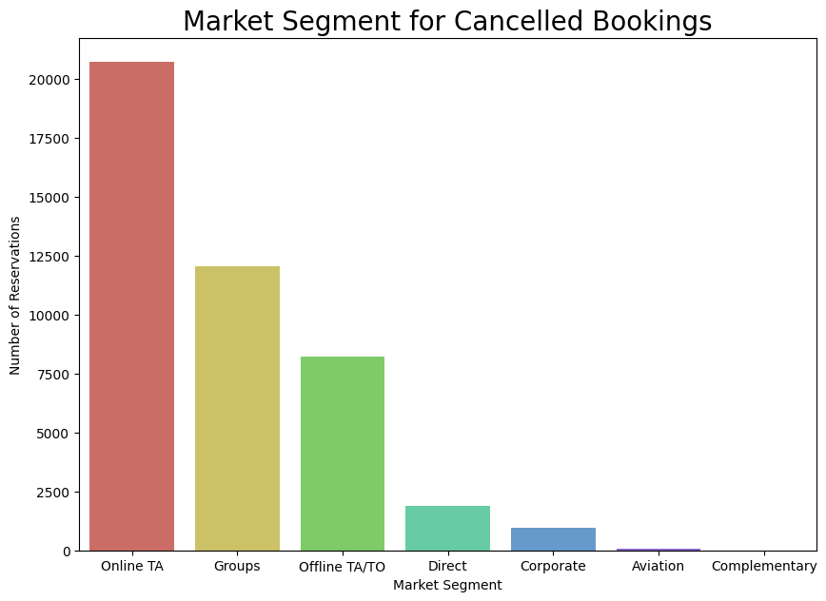

Above bar graphs demonstrates the most cancellations as per the market segment. As we can see, 47% reservations are cancelled by Online TA which is the highest.

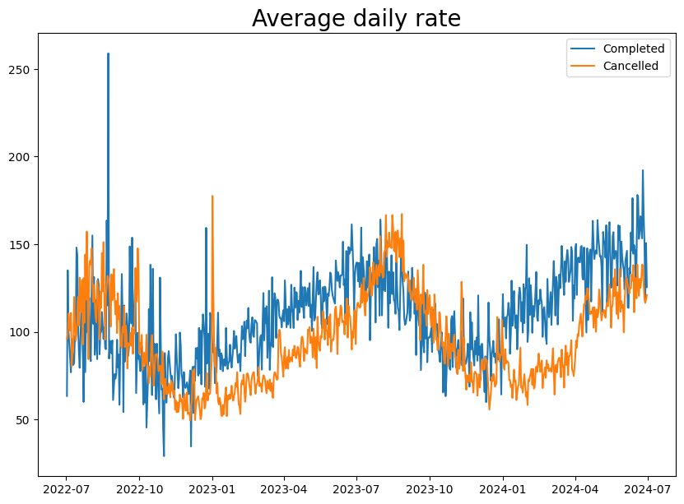

From the above graph we can observe that the reservations are cancelled when the average daily rate is high.

**Conclusions:**

1. From the above analysis, I conclude that the higher price leads to the higher cancellation rate.
2. In the month of January, there are more number of cancellations and in September, they are low.

**Suggestions:**

1. In order to decrease the cancellation rates, the hotel have to work on their price strategies and try to give discounts to the customers.
2. In the starting of the year, they can start campaigns and marketing to attract more customers to increase the revenue.
3. They should upload clear and real-time pictures of the rooms in the online website or application so that when the customers reach the hotel and compare with those pictures, they can feel satisfied.
4. They can work on their quality of the service provided to the customers so that the customers don’t give bad reviews.
5. You should start more campaigns, give offers or discounts to the customers from Portugal so that they don’t cancel the bookings.